

PROJECT





COMSATS University Islamabad

**Abbottabad Campus**

Project: **HURRICANIX e-LEARNING**

*By*

**SYED SHAH HUSSAIN CIIT/FA21-BSE-172/ATD**

**MAHAD WAJID CIIT/FA21-BSE-057/ATD**

*Supervisor****MA’AM NEELI KHAN***

*Bachelor of Science in* ***SOFTWARE ENGINEERING***

***(2021-2025)***

Table of Contents

1 Introduction: 5

1.1 Purpose: 5

1.2 Project Scope: 6

1.3 Document Conventions: 7

1.4 References: 7

2 Overall Description: 7

2.1 Product Perspective: 7

2.2 User Classes and Characteristics: 7

2.3 Operating Environment: 8

2.4 Design and Implementation Constraints: 8

2.5 Assumptions and Dependencies: 8

3 System features: 8

4 Data requirements: 9

4.1 Logical data model: 9

4.2 Data dictionary 10

4.3 Reports 11

4.3.1 Course Enrollment and Completion Report 11

4.3.2 Instructor Performance Report 11

4.3.3 Student Progress and Engagement Report 11

4.3.4 Course Category Analysis Report 12

4.3.5 Revenue and Profitability Report 12

4.3.6 Customer Demographics and Behavior Report 12

4.3.7 Course Feedback and Ratings Report 12

4.3.8 Platform Performance Report 12

4.3.9 Retention and Churn Report 12

4.3.10 Completion Time Analysis Report 13

4.4 Data acquisition, integrity, retention, and disposal 13

5 External interface Requirements: 14

5.1 User interfaces 14

5.1.1 User-Friendly Interface 14

5.1.2 Visual Appeal 14

5.1.3 Responsiveness 14

5.1.4 Clear Instructions and Feedback 14

5.2 Software interfaces 14

5.2.1 Database Connectivity 14

5.2.2 Secure Payment Processing 14

5.2.3 Order Fulfillment and Tracking 14

5.3 Hardware interfaces 15

5.3.1 Compatibility with Hardware Devices 15

5.3.2 Printer Connectivity 15

5.4 Communications interfaces 15

5.4.1 Push Notifications 15

5.4.2 Email Communication 15

5.4.3 Analytics and Tracking 15

6 Quality attributes 15

6.1 Usability 15

6.1.1 Ease of Use 15

6.1.2 Search Functionality 16

6.1.3 Information 16

6.2 Performance 16

6.2.1 Speed 16

6.2.2 Reliability 16

6.2.3 Scalability 16

6.2.4 Availability 16

6.3 Security 17

6.3.1 Data Protection 17

6.3.2 Payment Security 17

6.3.3 Content Access Control 17

6.4 Safety 17

6.4.1 Content Reliability 17

6.4.2 Privacy Compliance 17

6.4.3 Content Safety 17

6.5 Other Attributes 17

6.5.1 Sustainability 17

6.5.2 Community Engagement 17

6.5.3 Educational Impact 18

7 Internationalization and Localization Requirements: 18

7.1 Internationalization Requirements: 18

7.2 Localization Requirements: 18

8 Appendencies: 18

8.1 Appendix A: Glossary 19

8.2 Appendix B: Analysis Model 19

8.2.1 DFD: 19

8.2.2 Decision Tree: 21

8.2.3 Decision Table: 22

8.2.4 Response Table: 23

# Introduction:

Our HURRICANIX eLEARNING platform is designed to make learning accessible and convenient for everyone. With our online platform, you can access a wide range of courses and materials on various subjects, all in one place. Whether you're a student looking to supplement your education, a working professional looking to upgrade your skills, or simply someone who wants to learn something new, our app has something for you. With interactive features, quizzes, attempting assignment in real-time with integrated applications and progress tracking, our app makes it easy to stay engaged and motivated as you learn.

## Purpose:

"The fundamental goal of our E-Learning platform is to revolutionize education accessibility and engagement by:

* Providing a diverse range of courses and materials accessible from anywhere, catering to students, professionals, and lifelong learners.
* Fostering interactive and engaging learning experiences through quizzes, real-time assignments, and integrated applications.
* Tracking individual progress to personalize learning journeys and enhance motivation.
* Offering a seamless learning experience that transcends geographical limitations, making education convenient and adaptable to varying schedules.
* Empowering learners by simplifying the learning process, thereby promoting continuous personal and professional development."

## Project Scope:

* **Objective:** Develop an E-Learning Platform to revolutionize accessibility and engagement in online education.
* **Features:**
  + Centralized repository for diverse courses and study materials.
  + User-centric interface catering to students, professionals, and lifelong learners.
  + Offline learning functionality allowing video lecture downloads.
  + Interactive tools like real-time assignments, quizzes, and progress tracking.
  + Personalized user profiles for tailored learning experiences.
* **Target Audience:** Students, working professionals, and knowledge enthusiasts seeking versatile educational resources.
* **Out of Scope:**
  + Hardware development or physical learning tool creation.
  + Content creation; the platform focuses on hosting existing educational materials.
* **Constraints:**
  + Stringent security measures for data privacy.
  + Compatibility across devices and operating systems.
  + Compliance with educational standards and regulations.
* **Deliverables:**
* Fully functional E-Learning Platform meeting specified requirements.
* Comprehensive user documentation for ease of use.
* Testing reports ensuring platform reliability.
* **Milestones:**
  + Development Phase: Platform creation, feature integration, rigorous testing.
  + Implementation Phase: Platform launch, user onboarding, feedback incorporation.
* **Success Criteria:**
  + High user engagement rates and positive feedback.
  + Minimal post-launch technical issues.
  + Positive user adoption reflected in usage metrics.

## Document Conventions:

## References:

Throughout the development of the E-Learning Platform project, the following references will be consulted:

* Academic research on educational psychology and pedagogy, focusing on online learning and engagement strategies.
* Industry best practices and guidelines for user interface design in e-learning systems.
* Reports and studies on educational technology trends and innovations, particularly in online course delivery and learner interaction.
* Publications and resources highlighting effective methods for content curation and instructional design in e-learning environments."

These references can serve as a foundation for understanding the pedagogical, technological, and design aspects essential for developing a robust and engaging E-Learning Platform. When using these references, it's important to properly cite and integrate them within the project documentation to support the platform's development and functionalities.

# Overall Description:

## Product Perspective:

The E-Learning Platform exists within the realm of online educational technologies. It functions as a centralized system aimed at providing a diverse range of courses and learning materials across various subjects. The platform operates as a standalone system, yet it may integrate with external tools or learning management systems for enhanced functionality or content sourcing.

## User Classes and Characteristics:

The platform caters to different user classes:

* **Students:** Seeking supplemental education or specific course completion.
* **Professionals:** Looking to upskill or expand their knowledge base.
* **Lifelong Learners:** Individuals interested in continuous learning and personal development. Each class possesses varying degrees of technical proficiency and learning objectives, driving the need for a user-friendly interface and personalized learning experiences.

## Operating Environment:

The E-Learning Platform operates in an online environment, accessible via web browsers across multiple devices such as desktops, laptops, tablets, and smartphones. It requires a stable internet connection for regular usage, with provisions for offline access to downloaded course materials.

## Design and Implementation Constraints:

* **Security Measures:** Stringent data protection protocols to ensure user privacy and safeguard sensitive information.
* **Compatibility:** Ensuring compatibility across different operating systems and devices for a seamless user experience.
* **Educational Standards:** Compliance with educational guidelines and standards governing online learning.

## Assumptions and Dependencies:

* **Assumptions:** The platform assumes a certain level of user engagement and motivation in completing courses.
* **Dependencies:** Dependence on reliable internet connectivity for real-time usage; offline access feature reliant on device storage capabilities.

# System features:

|  |  |  |
| --- | --- | --- |
| Feature | Description | Requirements |
| User Profile Management | Manage user accounts and store information securely. | 1. Allow users to create, update, and delete profiles.  2. Ensure secure storage of user information. |
| Course Catalog | Display available courses with descriptions and categorization. | 1. List courses with details, objectives, and prerequisites. 2. Categorize courses for easy navigation. |
| Content Management System (CMS) | Upload, organize, and manage course materials (lectures, quizzes, resources). | 1. Support multiple formats for content.  2. Enable organization and easy access. |
| Learning Management System (LMS) | Track student progress, grading, feedback, and performance analytics. | 1. Record student progress and grades.  2. Provide performance insights and analytics. |
| Discussion Forums | Facilitate communication between students and instructors. | 1. Enable forums, chats, or messaging systems.  2. Support collaboration tools for group discussions. |
| Assessment and Evaluation | Create quizzes, exams, and assessments; automate grading and feedback. | 1. Develop various types of assessments.  2. Implement automated grading and feedback mechanisms. |
| Progress Tracking and Reporting | Allow students to monitor their progress; provide analytics for administrators. | 1. Provide progress tracking tools for students.  2. Generate reports for platform usage and course effectiveness. |
| Certification and Credentials | Issue certificates or badges upon course completion; maintain credential records. | 1. Generate and issue completion certificates.  2. Store earned credentials securely. |
| Mobile Compatibility | Ensure platform accessibility and functionality across devices. | 1. Develop a responsive design for different screen sizes.  2. Optimize usability on mobile devices. |
| Payment and Subscription | Manage payments for course enrollment or subscriptions. | 1. Implement secure payment processing.  2. Offer subscription management if applicable. |
| Accessibility Features | Ensure compliance with accessibility standards for users with disabilities. | 1. Adhere to ADA and other relevant accessibility standards.  2. Provide features for users with disabilities. |
| Content Recommendation | Suggest courses based on user preferences, history, and learning goals. | 1. Utilize user data to recommend relevant courses. 2. Implement personalization algorithms. |
| Security and Privacy | Implement robust security measures to protect user data. | 1. Ensure data encryption and secure user authentication.  2. Prevent unauthorized access to user information. |
| Technical Support and Helpdesk | Offer assistance to users facing technical issues or needing guidance. | 1. Provide helpdesk support for technical queries.  2. Offer resources for user guidance and troubleshooting. |

# Data requirements:

## Logical data model:

|  |  |  |
| --- | --- | --- |
| Entity | Attributes | Relationships |
| User | user_id (PK), usertype, username, email, password, other_user_attributes | - |
| Course | course_id (PK), title, description, other_course_attributes | - |
| Enrollment | enrollment_id (PK), user_id (FK - User), course_id (FK - Course), enrollment_date, other_enrollment_attributes | User (One-to-Many), Course (One-to-Many) |
| Video | video_id (PK), course_id (FK - Course), title, video_url, other_video_attributes | Course (One-to-Many) |
| Quiz | quiz_id (PK), course_id (FK - Course), title, questions, other_quiz_attributes | Course (One-to-Many) |
| Assignment | assignment_id (PK), course_id (FK - Course), title, description, other_assignment_attributes | Course (One-to-Many) |
| Project | project_id (PK), course_id (FK - Course), title, description, other_project_attributes | Course (One-to-Many) |
| Certificate | certificate_id (PK), user_id (FK - User), course_id (FK - Course), issue_date, other_certificate_attributes | User (One-to-Many), Course (One-to-Many) |

## Data dictionary

|  |  |  |
| --- | --- | --- |
| Attribute | Description | Data Type |
| course_id | Unique course identifier | Integer |
| title | Course title | String |
| description | Course description | String |
| instructor_id | Unique instructor identifier | Integer |
| category | Course category or subject area | String |
| price | Course price | Decimal |
| duration | Course duration (in hours) | Integer |
| level | Difficulty level (e.g., beginner, intermediate) | String |
| instructor_id | Unique instructor identifier | Integer |
| name | Instructor name | String |
| bio | Instructor biography | String |
| email | Instructor email | String |
| specialization | Instructor expertise area | String |
| student_id | Unique student identifier | Integer |
| name | Student name | String |
| email | Student email | String |
| address | Student address | String |
| enrolled_courses | List of enrolled course_ids for the student | List of Integers |
| lesson_id | Unique lesson identifier | Integer |
| content | Lesson content (text, video, documents) | String |
| sequence_number | Lesson order or sequence number | Integer |
| enrollment_id | Unique enrollment identifier | Integer |
| enrollment_date | Date of student enrollment in the course | Date |
| completion_status | Status of course completion | String |
| quiz_id | Unique quiz identifier | Integer |
| questions | Quiz questions | String |
| difficulty | Quiz difficulty level | String |
| attempt_id | Unique quiz attempt identifier | Integer |
| submission_date | Date of quiz attempt submission | Date |
| score | Score achieved in the quiz attempt | Decimal |

## Reports

### Course Enrollment and Completion Report

* Overview of course enrollments, completions, and dropout rates.
* Breakdown of popular courses based on enrollment numbers.
* Insights into courses with the highest completion rates.

### Instructor Performance Report

* Analysis of instructor effectiveness based on student feedback and course completion rates.
* Comparison of instructor ratings and their respective course performance.

### Student Progress and Engagement Report

* Tracking student progress, including lessons completed, quizzes taken, and average scores.
* Engagement metrics such as time spent per course or lesson and frequency of logins.

### Course Category Analysis Report

* Overview of the popularity of course categories or subjects.
* Insights into which categories attract more enrollment and completion rates.

### Revenue and Profitability Report

* Revenue generated from course sales, broken down by course and instructor.
* Identification of top-performing courses in terms of profitability.

### Customer Demographics and Behavior Report

* Analysis of student demographics, including age groups, geographic locations, and learning preferences.
* Insights into customer behavior, such as preferred course types or interaction patterns.

### Course Feedback and Ratings Report

* Aggregated feedback from students, including ratings, comments, and suggestions for improvement.
* Identification of courses with the highest and lowest satisfaction rates.

### Platform Performance Report

* System metrics like uptime, user traffic, and platform responsiveness.
* Identification of peak usage times and performance bottlenecks.

### Retention and Churn Report

* Analysis of student retention rates and reasons for churn or dropout.
* Insights into factors influencing continued subscription or enrollment.

### Completion Time Analysis Report

* Average time taken by students to complete courses.
* Identification of courses that are either completed quickly or take longer than average.

## Data acquisition, integrity, retention, and disposal

|  |  |  |  |  |
| --- | --- | --- | --- | --- |
| Data Type | Data Acquisition | Data Integrity | Data Retention | Data Disposal |
| User Profile | User registration | Validate against internal database for accuracy | As long as user | Securely delete from all systems upon account deletion |
| Course Information | Instructor uploads, admin input | Regular checks against course metadata and content | As long as | Securely delete or archive upon course deletion |
| Enrollment Records | User enrolls in courses | Ensure alignment with available course catalog | Until course | Securely delete or archive upon course completion |
| Learning Progress | User interaction with course materials | Tracking of progress, completion, and assessment data | Until course | Securely delete or archive upon course completion |
| Feedback and Ratings | User-submitted feedback and ratings | Moderation and validation for authenticity | As needed for | Securely delete or archive after specified time period |

# External interface Requirements:

## User interfaces

### User-Friendly Interface

* Easy navigation for users with varying technical abilities.
* Clear and intuitive design for seamless interaction.

### Visual Appeal

* Visually appealing design using appropriate colors and fonts.
* Tailored aesthetics for the target audience.

### Responsiveness

* Compatibility across multiple devices (smartphones, tablets, computers).
* Responsive design ensuring optimal viewing and interaction.

### Clear Instructions and Feedback

* Concise and clear instructions guiding users through the app.
* Real-time feedback to acknowledge user actions.

## Software interfaces

### Database Connectivity

Interface with a database containing course details, user information, etc.

### Secure Payment Processing

Integration with secure payment gateways for transaction processing.

### Order Fulfillment and Tracking

Interaction with shipping systems for order fulfillment.

Real-time tracking updates for users.

## Hardware interfaces

### Compatibility with Hardware Devices

Support for external devices like cameras, microphones, or interactive boards.

Integration with devices such as barcode scanners or payment terminals.

### Printer Connectivity

Interface with printers for receipt and invoice printing.

## Communications interfaces

### Push Notifications

Sending and receiving push notifications to inform users about updates or events.

### Email Communication

Automated emails for order confirmations, shipping updates, and notifications.

### Analytics and Tracking

Capture user interactions for analytics and reporting purposes.

# Quality attributes

## Usability

### Ease of Use

* + **Intuitive Interface:** User-friendly design with easy navigation and clear layouts.
  + **Accessibility:** Ensuring usability for users with diverse technical abilities.

### Search Functionality

* + **Robust Search Features:** Effective search options by course title, category, or keywords.
  + **Filtering Options:** Facilitating filtering by price, duration, level, or popularity.

### Information

* + **Comprehensive Course Details:** Detailed course descriptions, objectives, and prerequisites.
  + **Interactive Content:** Engaging multimedia content supplemented with additional resources.

## Performance

### Speed

* + **Responsive Design:** Fast loading times for pages and course materials.
  + **Optimized Performance:** Efficient resource utilization for seamless user experience.

### Reliability

* + **Stability:** Ensuring the platform's stability without frequent downtime or technical glitches.
  + **Consistency:** Maintaining consistent performance across different devices and browsers.

### Scalability

* + **Capacity to Scale:** Ability to handle increased user traffic and growing content demands.

### Availability

* + **24/7 Accessibility:** Ensuring continuous access to course materials and platform functionalities.

## Security

### Data Protection

* + **Secure Handling:** Protection of user data from unauthorized access or breaches.

### Payment Security

* + **Secure Transactions:** Implementing secure payment gateways for financial transactions.

### Content Access Control

* + **User Authentication:** Ensuring authorized access to paid or restricted content.

## Safety

### Content Reliability

* + **Accurate Information:** Ensuring educational content adheres to factual accuracy and reliability.

### Privacy Compliance

* + **GDPR and Data Privacy:** Compliance with data protection laws to safeguard user privacy.

### Content Safety

* + **Moderation:** Monitoring content for inappropriate or misleading information.

## Other Attributes

### Sustainability

* + **Eco-friendly Practices:** Promoting sustainability in content creation and platform operations.

### Community Engagement

* + **Interactive Forums:** Providing a platform for users to interact, share insights, and collaborate.

### Educational Impact

* + **Learning Outcomes:** Measuring and ensuring the effectiveness of courses in achieving learning objectives.

# Internationalization and Localization Requirements:

## Internationalization Requirements:

1. **Currency Handling:** Support multiple currencies and implement localized currency formatting, including symbols, decimals, and placement.
2. **Language Support**: Design the platform architecture to accommodate multiple languages seamlessly.
3. **Cultural Adaptability**: Develop features that can adapt to different cultural preferences, date formats, and numeric systems.
4. **Content Separation**: Separate user interface elements from content to facilitate easy translation without altering the system's functionality.
5. **Dynamic Content Handling**: Enable dynamic content adjustments based on language preferences without altering the system's core structure.
6. **Responsive Design**: Ensure the platform's design is adaptable to different screen sizes and orientations, considering diverse devices used globally.

## Localization Requirements:

1. **Translation Support**: Facilitate easy translation of platform content into different languages by providing translation management tools or integration with translation services.
2. **Cultural Adaptation**: Customize content to suit local norms, values, and cultural sensitivities of various regions or countries.
3. **Localized Content**: Offer region-specific content or courses tailored to the needs and interests of different user demographics.
4. **Date, Time, and Currency Formats**: Customize date, time, and currency formats based on regional preferences.
5. **Localized Media**: Provide support for localized images, videos, and audio content, considering cultural references and preferences.
6. **User Interface Adaptation**: Adjust the user interface elements such as buttons, menus, and labels to match the language and cultural context of users.

# Appendencies:

## Appendix A: Glossary

## Appendix B: Analysis Model

### DFD:

#### Level 0:

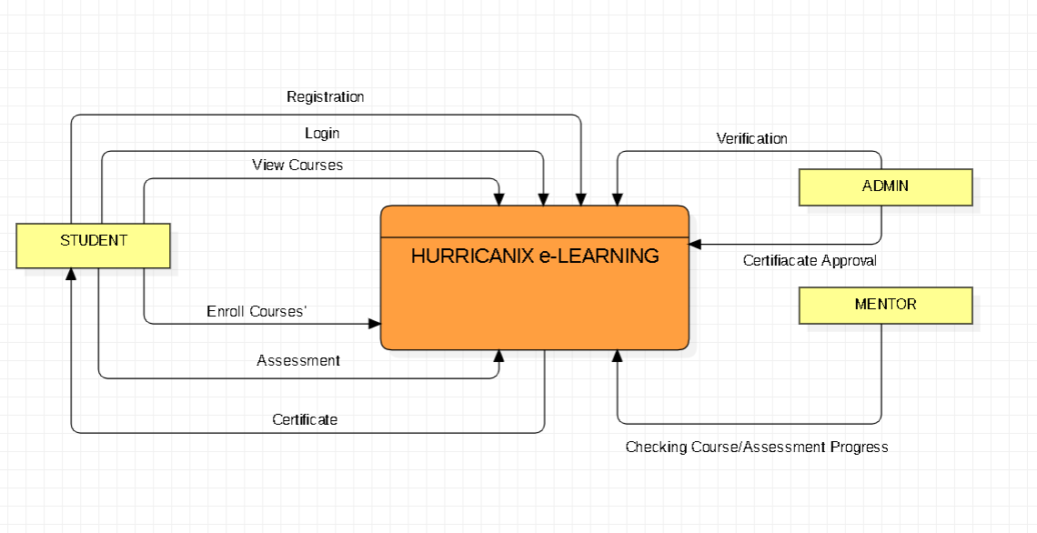

#### Level 1:

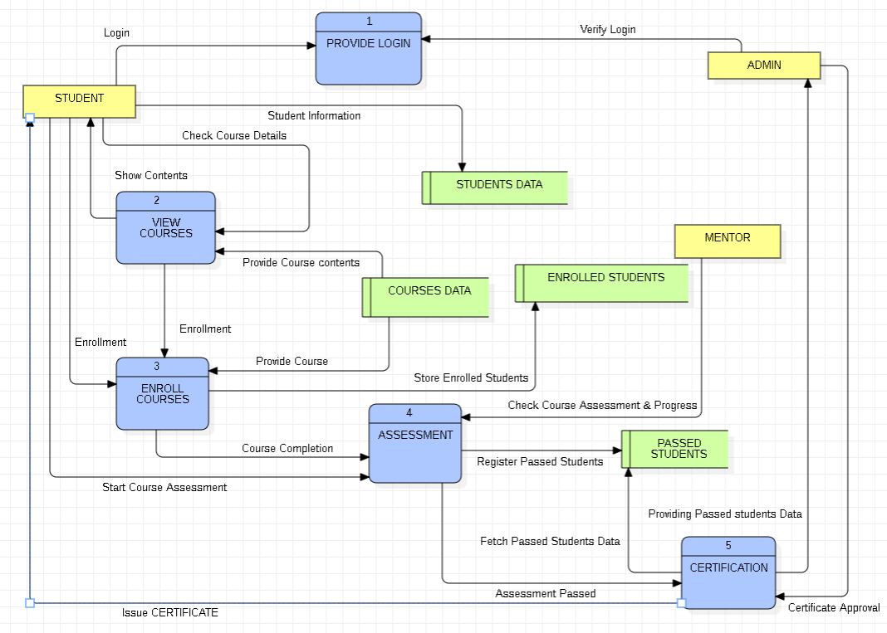

#### Level 2:

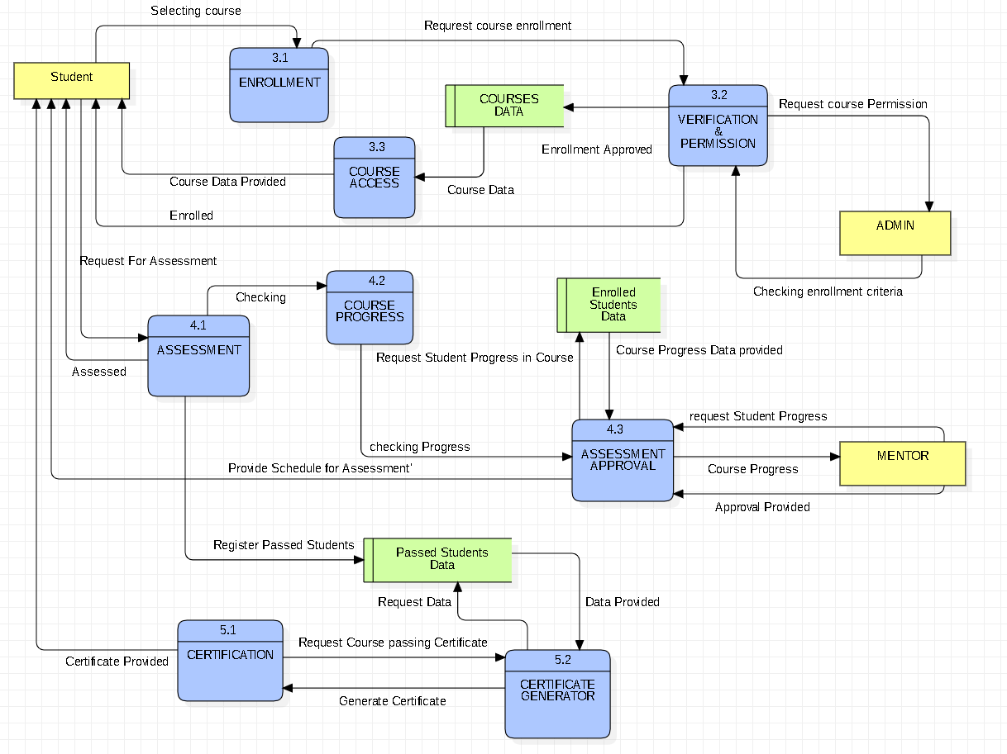

### Decision Tree:

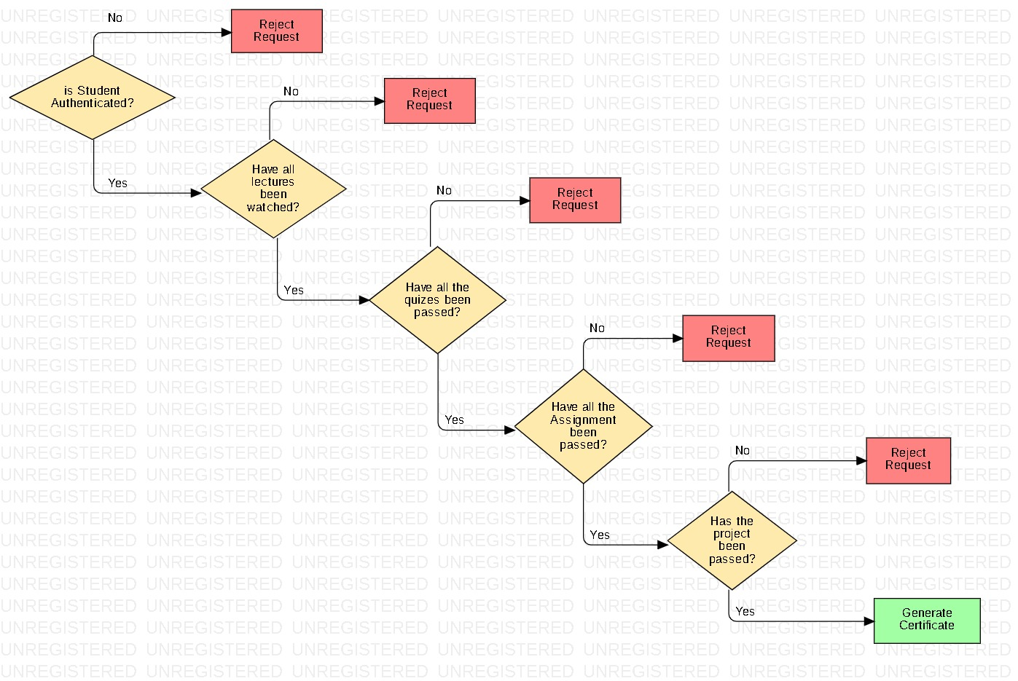

### Decision Table:

|  |  |  |  |  |  |
| --- | --- | --- | --- | --- | --- |
| **Condition** | **1** | **2** | **3** | **4** | **5** |
| Student is Authenticated | True | True | True | True | True |
| All lectures watched | True | False | True | True | True |
| All quizzes are passed | True | False | True | True | True |
| All Assignments are passed | True | True | False | True | True |
| Project passed | True | False | False | True | True |
| **Action** |  |  |  |  |  |
| Generate Certificate | Yes |  |  | Yes | Yes |
| Criteria not Met |  | Yes | Yes |  |  |

### Response Table:

|  |  |  |  |
| --- | --- | --- | --- |
| ID | Event | System State | System Response |
| 1 | User attempts to login | User is on the login page | Prompt user to enter their credentials |
| 2 | User enters valid credentials | User is on the login page | Verify user credentials against the database |
| 3 | Credentials are valid | User is on the login page | Grant user access to the platform |
| 4 | Credentials are invalid | User is on the login page | Display error message indicating invalid credentials |
| 5 | User clicks on a course | User is on the home page or browsing courses | Display detailed information about the selected course |
| 6 | User clicks on the "Enroll" button | User is viewing a course | Check if the user is already enrolled in the course |
| 7 | User is not enrolled in the course | User is viewing a course | Display payment options for enrollment |
| 8 | User selects a payment method | User is viewing a course | Process payment and enroll the user in the course |
| 9 | Payment is successful | User is viewing a course | Enroll the user in the course |
| 10 | Payment is unsuccessful | User is viewing a course | Display payment failure message and prompt user to try again |
| 11 | User clicks on an assessment | User is enrolled in a course | Check if the user has completed the prerequisite assessments |
| 12 | User has completed prerequisite assessments | User is enrolled in a course | Display the assessment |
| 13 | User completes the assessment | User is enrolled in a course | Record the user's assessment score |
| 14 | User clicks on the "Generate Certificate" button | User has completed all course requirements | Verify if the user has completed all course requirements |
| 15 | User has completed all course requirements | User has completed all course requirements | Generate and display the certificate |
| 16 | User has not completed all course requirements | User has completed all course requirements | Display message informing the user that they have not completed all course requirements |
| 17 | User clicks on the "Logout" button | User is logged in | Terminate the user's session and redirect them to the login page |

### State Transition Matrix/ Table:

|  |  |  |  |  |  |
| --- | --- | --- | --- | --- | --- |
| Current State | Select Course | Enroll Request | Confirm Enrollment | Enrollment Rejected | Cancel Enrollment |
| Initial State | Course Selection | - | - | - | - |
| Course Selection | - | Enrollment Pending | - | - | - |
| Enrollment Pending | - | - | Enrolled | Enrollment Failed | Cancelled |
| Enrolled | - | - | - | - | Cancelled |
| Enrollment Failed | - | - | - | - | - |
| Cancelled | - | - | - | - | - |